**Almost Final Edits/Questions!**

**September 8, 2016**

1. Main Page left search box: SO pleased that you could add the drop down list, thank you, that is so much better! ☺

is it possible to search for a particular instructor or gym? For example, if they enter “Gold’s” for “Gold’s Gym” on the left, they would start to get a list that has “Gold” in it (Zumba Gold, Gold’s Gym, Frank Goldfield” but then if they click “Instructors” on the right, it would only show instructors with “Gold” in their name? Or if they click “Facilities” it then refines the results on the left to only “Gold’s Gym”? Not sure if this is possible but it would be IDEAL if we could do that. **[?DNT UNDRSTAND]**

1. There needs to be a “Contact” link in the footer under “Support”. Contact message would go to the same place as “Contact Us” in the profile pages. [admin@look4fitness.com](mailto:admin@look4fitness.com)? Please also add the phone number, which is 1-800-948-3006 **[DONE]**
2. You can remove the “How It Works” video from the main page now, since it is on “About Us”. It should go from Featured Members to the footer.**[DONE]**
3. Regarding Chrome and location: Not Possible at the moment. We have done using google api services which is only free service. For chrome google api does not support on http://. If you install https:// then it will automatically start working.)

**What is the cost/process of doing https so that the IP/Location feature works?[?]**

1. Sorry about all the confusion with Yoga and Pilates. Somehow they are classified under “Personal Training”. I went in and created a new category “Mind/Body” for both Yoga and Pilates. I couldn’t find how to enter the child classes, but if you can do that, it would be very helpful. So examples are:**[DONE]**

Mind/Body: Yoga: Hatha

Mind/Body: Yoga: Vinyasa

Mind/Body: Pilates: Reformer

Mind/Body: Pilates: Mat

Personal Training: Personal Trainer

Personal Training: Wellness Coaching

Etc…..

Sorry, that was probably my fault! All the other Parent/Child categories (Ballet, etc.) look great now!! ☺

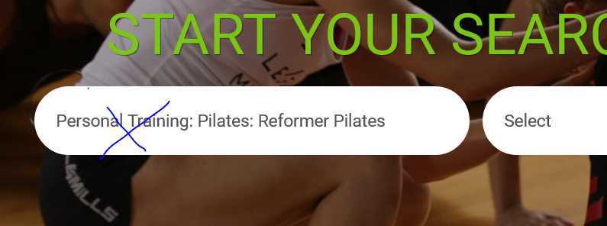

1. After searching under “Yoga”, the Jessica Lindenfelser Profile showed up, but there is no Yoga in the profile, so something is pulling the wrong criteria:**[[DONE]]**

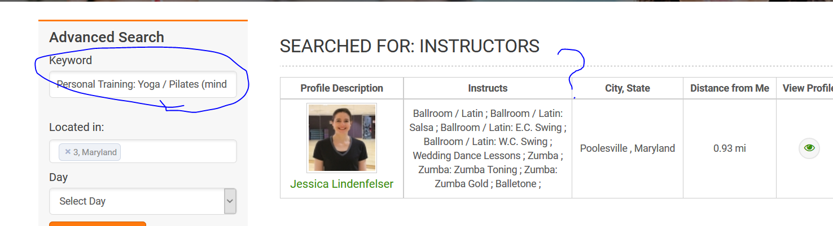

I also entered “Aerial Dance” on the main page, and got my profile, but I do not teach Aerial Dance, and it is not mentioned in my bio. I think it is pulling me because of the default location. I know that the profile for [ArkoChatterjee](http://look4fitness.net/users/profile/3) has Aerial Dance in it. That profile should appear, even though it is far away. The list should show the closest options up top, followed by things that are further away. Maybe we could add a box where they enter radius, so that there aren’t hundreds of results for the more popular items like Zumba and Yoga? **[[DONE]]**

1. Regarding your comment below about word matches: **There is lablast in “about me” part of Jessica and as about me is in the content part therefore for keyword search its working and Jessica is getting selected . Frank told me any word match to the profile will come up on the search list in earlier document.**

I see why he said that, and in some ways it’s helpful, but the problem is that when I enter “Personal Training” in the search box (which many people will do), my profile comes up because the word “training” is in “about me”, but that is referring to my dance training, and not to being a personal trainer. I am worried that word matches will produce a lot of “false positives” and it will annoy the users to look for personal training and find a bunch of people who are not personal trainers. Someone else might say in their bio “I have a background in ballet” but they aren’t actually a ballet teacher. That would also pull them up incorrectly. Is it possible to change it so that it only pulls from the Listing Details of their profile? Unless you have other suggestions?**[PRESENTLY “ABOUT ME” IS INCLUDED IN THE SEARCH FIELDS ,NOW YOU ARE REQUESTING TO REMOVE THE “ABOUT ME” FROM THE SEARCH FIELDS.IT CAN BE DONE EASILY BUT LATER IF YOU ADD ANY CLASSES/CATEGORIES IN THE ABOUT ME SECTION THEN YOU WON’T GET THAT PROFILE LATER ON IF YOU SEARCH BY THOSE CATEGORIES/CLASSES.]**

1. On the main search page, I entered Ballet, and then chose “Classes”. It defaulted to Thursday (which is today), and picked ballet, but it also picked classes that had nothing to do with Ballet. The same thing happened using “Today’s Classes” and choosing Ballet. Maybe again because it was choosing the word ballet from my bio? It should ONLY pick ballet classes. **[DONE]**

NOTE: The same day default is only for “Today’s Classes”. The general search box should show ALL classes (that are ballet or whatever was searched) filtered by location – perhaps up to 100 results before having to be refined further.**[?DNT UNDRSTAND]**

Also, the user should be able to enter MULTIPLE keywords so they can filter by several class types. So if they choose keywords for Ballet and Zumba, it will list all of the Ballet classes followed by all of the Zumba classes, with the closest classes at the top, by date/time.**[DONE]**

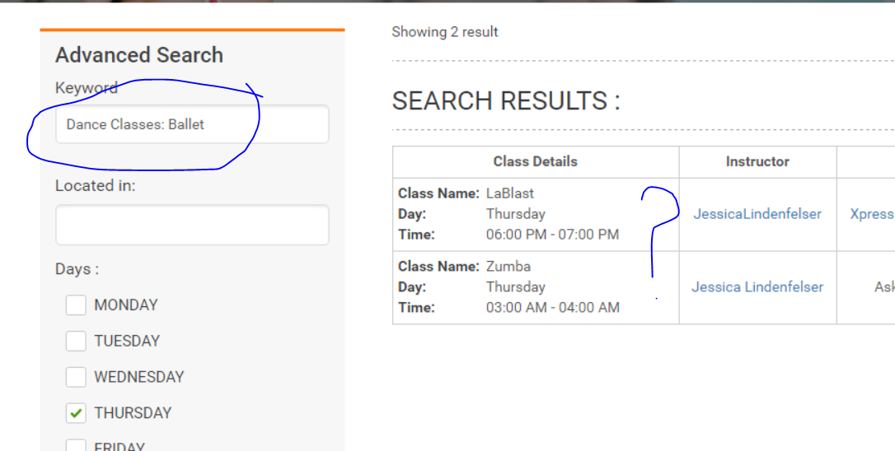

1. On the Jobs page, employment type “( Temporary )” is not wrapping correctly, probably because there is a space between the word and the parenthesis, which makes the parenthesis seem like another word, so it wraps. Please ensure that there are no spaces between words and parenthesis, i.e. (Temporary).**[****DONE]**

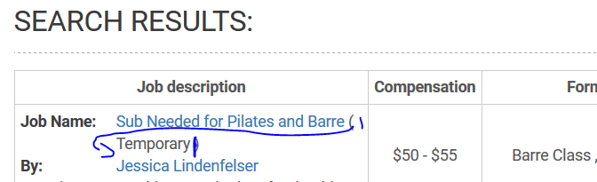

1. Also, there are still gaps before colons in various locations throughout the site (today’s classes results, etc.). Can you do a global change to remove all gaps before a colon throughout the site? **[****DONE]**



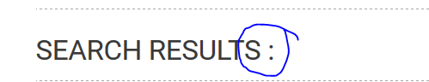**[DONE]**

1. Currently people who are not logged in can view class details by clicking on the eyeball:

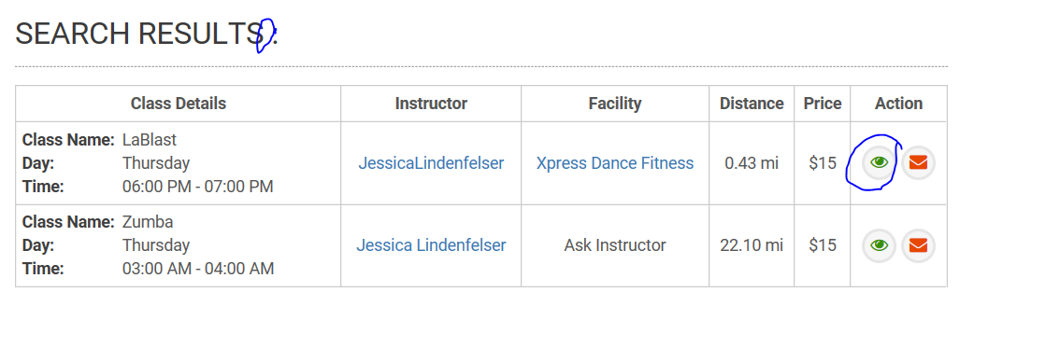

They should only be able to see the details if they are registered and logged in.**[DONE]**

1. Both Jobs and Profiles are now showing the following message:

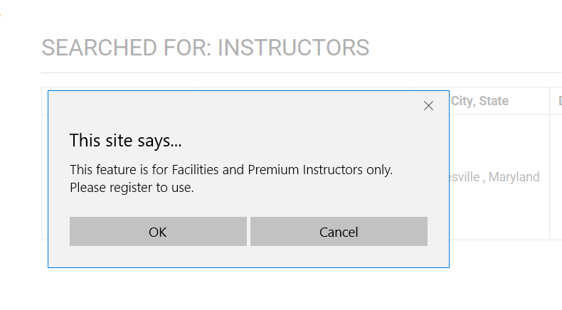

The message about Premium and Facilities above should only apply to Power Search, and posting of jobs, which are both features for facilities and premium instructors.

However, viewing of Jobs, Class Details and Profiles can be done by anyone (customers, basic instructors, premium, etc.) as long as they are registered. So we need the job page, view class eyeball and profile view message to say “**This feature is for registered members only. Please register or login to use”[****DONE]**

1. One of the goals for jobs was that once a job was posted, if there are members who have the qualifications (example, they post a job for Zumba in Frederick, MD), a notification will go into their inbox alerting them to the job. Can we have the alert go into “Jobs” in their profile side panel? **[left]**
2. I am wondering why the green box in Today’s Classes still shows “3, Maryland” (and sometimes it shows nothing), but the advanced search defaults to Poolesville? Shouldn’t they match/use the same locator?**[?left DNT UNDRSTAND]**

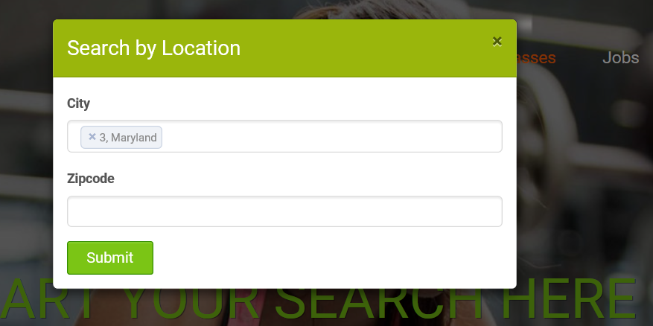

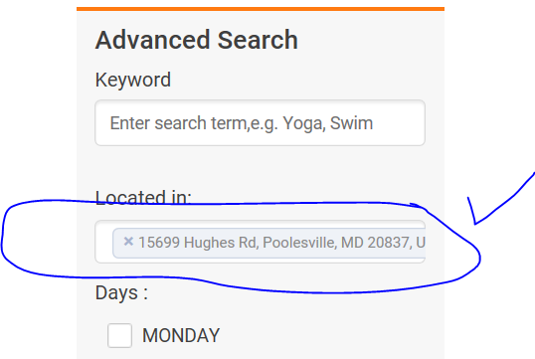

1. Some of the advanced panels have the times, and others require entry of the weekday first. Can we make them all the same to be consistent? I prefer having all the days and times showing, so they can select multiple days and times at once, the other way they can only pick one day at a time.**[design DONE]**

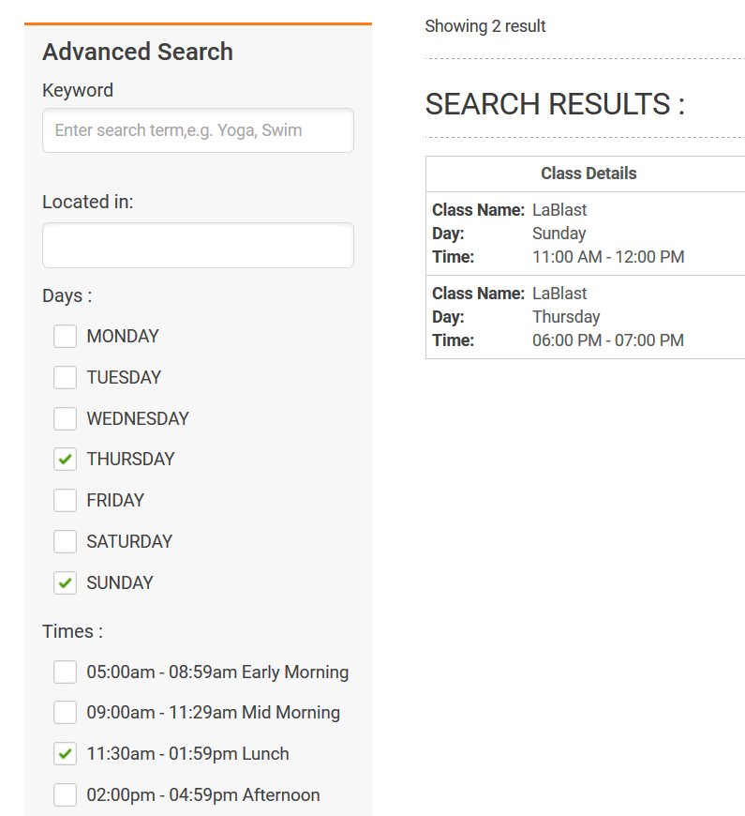

1. When an instructor is associated with a facility, the first/last names are still stuck together in a few places:**[DONE]**

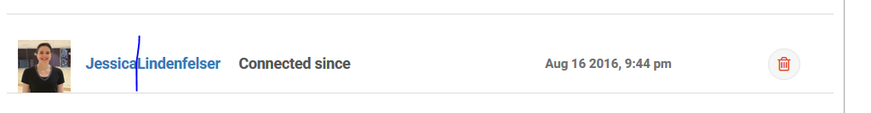

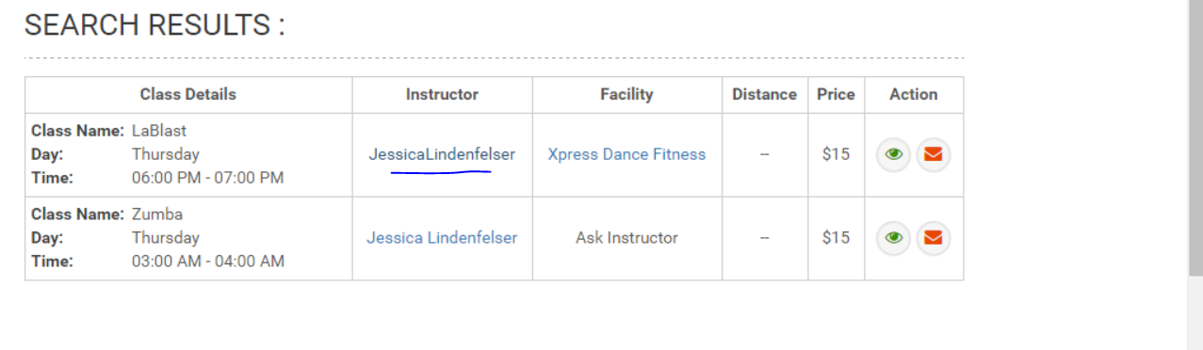

1. Can we have a list of all of a facility’s scheduled classes on their profile page (that the member can see by clicking on their profile) with the links to their instructors who teach? And the same on the Instructor’s page…all of the classes they teach and a link to the facility? It’s the same sort of format as “Today’s Classes” but it’s all at the one facility or for the one instructor. This way if the public clicks on an instructor’s profile, they can see all the classes they teach, and vice versa. Does this make sense?**[DONE]**
2. I posted a review as a facility (Xpress Dance & Fitness), but it shows up with the contact name (JessicaLindenfelser – which should be 2 separate words). Everything that comes from the facility should come from the facility name, not the contact name.**[DONE]**

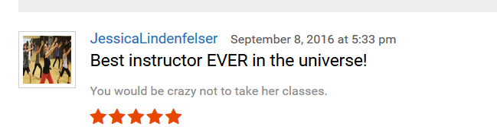

1. If a facility or instructor does NOT want their profile to be seen/searched for any reason, can we add a button called “Hide Profile” that hides their profile from searches until they turn it back off?**[ Next phase]**
2. When a facility adds a class, and their instructor is NOT a member, they need to be able to add the class without forcing an instructor name. Then when the class shows in a list, it would say “Ask Facility” the same way, it says “Ask Instructor” when the facility is not a member.**[ Next phase]**

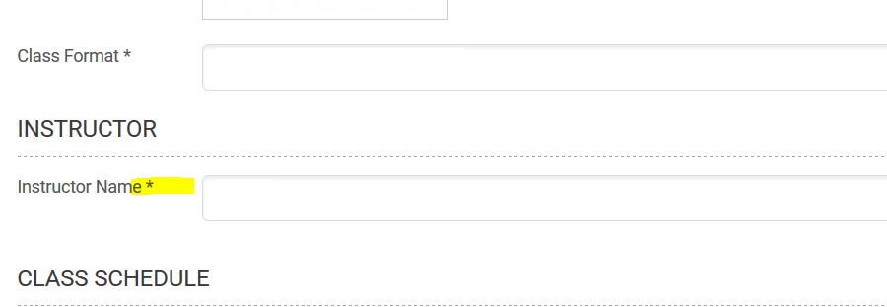

**POWER SEARCH**

Looking much better!

1. Change “Format” to “Class/Session Type” **(done) – It still says Format[DONE]**

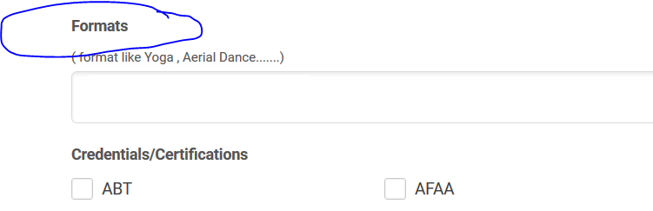

1. The side panel still has “Format” as well. Needs to be removed. It is replaced with Keyword, which currently doesn’t populate. We should be able to enter multiple keywords, like Ballet and Ballet: Checchetti for example. If we can enter an instructor’s name too, that would be great!**[DONE]**

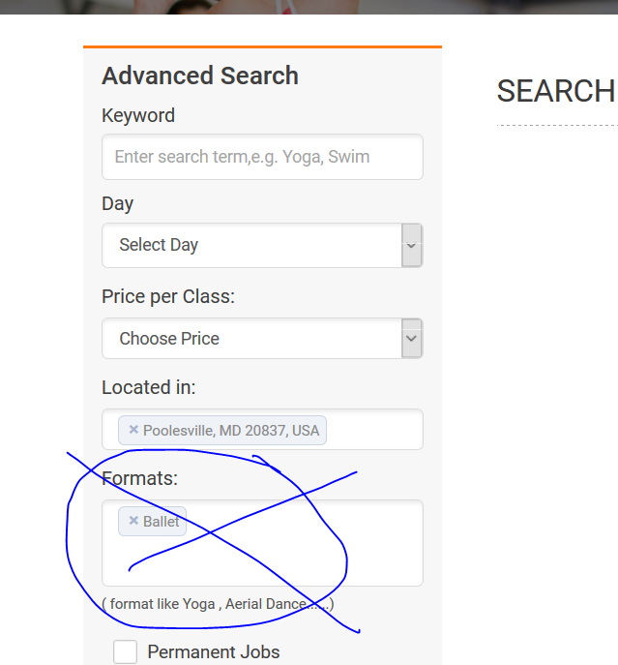

1. Need to show that there is a message waiting in the inbox (for both instructors and facilities). Currently there is nothing, even though there were new messages. This is working correctly under Reviews. I’d like it to be the same.**[DONE]**

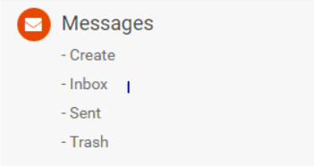

1. **IMPORTANT:** Need Power Search messages to go to the instructor’s phone (by text) AND to their personal email. This contact info is in their profile. This is not yet happening. Power Search is for urgent requests, so messages must get to the instructor in several ways, asap! **[For phone message sms api need to integrate and will do in next phase, That time also do email sending feature]**
2. Eyeball doesn’t do anything (in messages)?**[****DONE]**
3. **Question:** Is there a way someone can look up a list of instructors who teach for a specific gym using Power Search? For example, someone wants to know who teaches Zumba at Gold’s Gym. We would add a line for facility in the power search. So they search for Zumba and Gold’s Gym (and any other criteria), and a list of Gold’s Gym Zumba instructors shows up. This would be very helpful for people who want to work within their own gym chain. Can this be done?**[Not possible]**

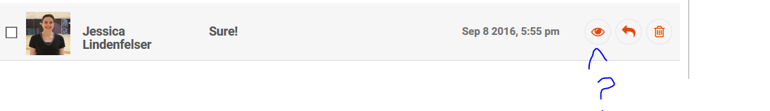

**ADDING CLASSES**

1. Is it possible to add a class that has multiple days/times at the same location? Right now, I have to re-create the same class several times if I want to use different days/times. Can we select multiple days/times for a class, like Tuesdays at 3 and Fridays at 5?**[Yes possible. But to do this it will need to huge change through out the side. So, this will be done in next phase]**
2. I attempted to create a class and select a facility. I tried entering Xpress Dance and Fitness and it wouldn’t come up. If a facility is a member, I should be able to select it for a class.**[DONE]**

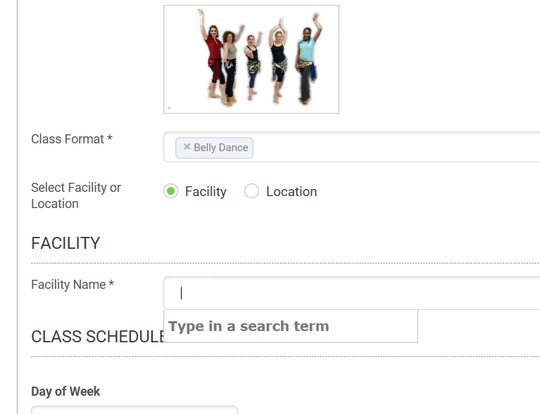

**BASIC INSTRUCTORS**

1. I registered a basic instructor (Jessica Moes) and this profile contains Power Search (at top), job posting and reviews. Basic instructors do not get to post jobs, use power search or receive reviews. Please edit accordingly. **[DONE]**

**WORK HOURS (all member types)**

1. Is it possible to have a couple of options for work hours each day? Right now you have to pick one timeframe, like Monday from 9-5. What if I am available on Monday from 9-1 and from 3-6? Could this be accomplished by adding an extra column or two? **[ Yes possible. But to do this it will need to huge change through out the side. So, this will be done in next phase]**

**REGISTRATION**

1. Please leave the green bar up on their screen (the one telling them their registration is not yet complete) until they hit an “OK” button, to make sure they see the message. It is very fast and hard to see.**[DONE]**
2. For registration email add “a” before Customer, Facility or Instructor. “Registering with us as a Customer.” For the last sentence, make community have a small “c” and remove “Member”. So it reads, “…thank you for becoming a member of the look4fitness.com community as a Customer.”**[DONE]**
3. **Currently Vendor Profiles are very bare bones and they can’t add any of their products, etc. We need to work out how their ads will be placed (“suggestion” ads when people view classes, etc). If Vendors are going to be part of the next phase, can we hide them from the main page and from “Join” for now so people won’t try to search/access them? [DONE]**

**REVIEWS**

1. Customer needs to have a list of reviews they have made in their profile under “Reviews” on side panel. They should be able to click “My Reviews” and see a list of reviews, edit them, or delete them.
2. The admin should be able to delete a review on a user’s profile if needed (in case of harrassment, profanity, etc.) **[?]**

**ADMIN**

1. There is no delete all button for users, can we add so it matches jobs, classes, events, etc?
2. We need to be able to change a user’s password. There is currently no ability to do that.**[WILL DO]**

**FOOTER**

1. Need to link Facebook icon with Facebook page: **https://www.facebook.com/Look4Fitness[DONE]**

**ABOUT US**

1. Formatting is still a little off. The questions in italics should be on the far left, and the answers indented. **[WILL DO]**

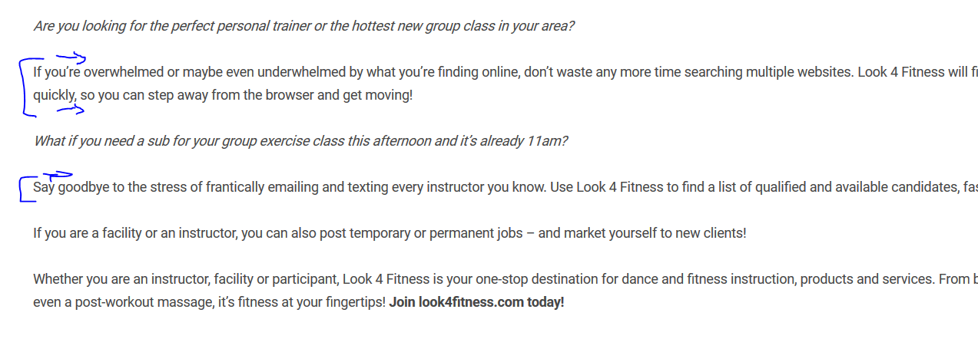

**FAQ [WILL DO]**

NOTE: Please replace the current text with this text for the FAQ:

**General**

**Do I need to become a member to use this site?**

* Anyone can use the search features on the home page of our site, but to view instructor profiles, job postings or class details, you will need to register with your name and email address.
* For the general public (“Customers”) and Instructors with basic memberships, registration is FREE!
* If you are a gym, school, fitness center or studio (“Faculty”), or an Instructor with a Premium Membership (monthly or annual subscription) you will receive a series of additional benefits. A list of benefits can be found by clicking the Instructor or Facility membership buttons on the home page of the website.

**How do I join?**

* Choose the appropriate membership category on the home page of the site, and click “Sign Up” or go to the top right corner and click the orange “Member Login” button. If you haven’t already registered, it will give you the option to sign up.

**How much is a membership?**

* **Customer Memberships** are free!
* **Basic Instructor Memberships** are free!
* **Premium Instructor Memberships** are $19.99/month, or $199/year (2 months free).
* **Facility Memberships** are $29.99/month or $299/year (2 months free).

**Where would I find an event near me?**

* On the home page of the site there is an “Events” box that features all of the events taking place in your area, based on your IP address or a city you select. Or, click “Events” at the top right of each page.

**Where would I find a class near me?**

* On the home page of the site is a “Today’s Classes” box, which shows all of the classes in your area, which you can filter by class type. “Today’s Classes” can also be found at the top of each page of the site.
* There is also a main search box, where you can look for facilities or instructors in your area, based on your IP address or a city you select.

**Can I leave a review for the instructor or facility?**

* You can leave a review for Premium Instructors and Facilities on their profile pages.

**How do I access or edit my profile?**

* Once you have logged in to the site, you will automatically go to your profile page. You will also notice your name and picture in the top right corner. If you leave your profile and want to get back to it, simply click on your name/picture and it will bring you back to your profile.

**I have a technical problem, who do I contact?**

* If you are already in your account, simply click “Contact Us” (bottom left of your side panel). If you are unable to access your account, please leave us a detailed message using the “Contact” button (under “Support” at the bottom of each page of the site), or call 1-800-948-3006. We will respond as soon as we can.

**How do I change or cancel my membership?**

* You can upgrade or downgrade your membership using “Manage Account” towards the bottom left of your profile page. If you’d like to close your account, click Contact us” (bottom left of your page) and we will close your account.

**What is your privacy policy?**

* Our privacy policy is outlined under “Privacy Policy” under “Support” at the bottom of each page.

**Instructors**

**What if the class/specialty I teach or my credential type is not listed?**

* Please click “Contact Us” from your profile page and request your class/credential. We are always happy to add new formats and credentials as needed!

**Can I link my account with another member?**

* Yes! If you are an instructor and the facility you work for is also a member, you can cross link to each other by clicking “Manage Facility”. You can also add the facility’s name to any classes you schedule on your profile (but only if they are a member).

This way, when someone searches for classes, it will show both your account and a link to your facility’s account, and vice versa. If your facility is not a member, it will say “ask instructor” and they can message you to ask where the class is taking place.

**How do I find a sub for my class?**

* If you are a Basic Instructor, you can search on your class type and location in the search box on the main page, and contact any appropriate instructors that appear in the results.
* If you are a Premium Instructor you can use “Power Search”, which allows you to find an instructor using much more detailed criteria, such as the days/times they are available, interest in subbing or permanent positions, credentials, CPR, insurance, fitness specialties, where they can travel etc.).

Once you have refined your list of instructors, you can contact all of them at once (or just a select few) and the message will go to their look4fitness inbox, their phone via text and their email. You can then select an instructor who replies to your message, and send another group message indicating you have filled the position. It’s a constantly updated list of staff that fit the exact criteria you are looking for with a click of a button!

**How do I apply for jobs?**

* You can either visit the Jobs page, or, if a facility or premium instructor posts a job, and you fit the qualifications, the job will be delivered to your inbox!

**How do I promote my classes/events?**

* Simply go to “add a class” or “post an event” on the side panel of your profile, and your class or event will show up whenever someone does a search!

**How do I post articles/content?**

* Go to “Add Articles” on the side panel of your profile to add your own content!

**Facilities**

**How do I hire an instructor/trainer/coach?**

* You can either do a search for the criteria you are looking for using Power Search and contact a member instructor directly, OR you can post a job on the job board. If an instructor is a match, your job will go directly into their in-box!

**What is Power Search?**

* “Power Search” allows you to find an instructor using much more detailed criteria, such as the days/times they are available, interest in subbing or permanent positions, credentials, CPR, insurance, fitness specialties, where they can travel etc.).

Once you have refined your list of instructors, you can contact all of them at once (or just a select few) and the message will go to their look4fitness inbox, their phone via text and their email. You can then select an instructor who replies to your message, and send another group message indicating you have filled the position. It’s a constantly updated list of staff that fit the exact criteria you are looking for with a click of a button!

**How do I post a job?**

* Click “Post a Job” on the side panel of your profile. You can post unlimited jobs with your membership!

**Can my instructors link to my account?**

* Yes! If your instructor is also a member, you can cross link to each other by clicking “Manage Instructor”. You can also add the instructor’s name to any classes you schedule on your profile.

This way, when someone searches for classes, it will show both your account and a link to your instructor’s account, and vice versa. If your instructor is not a member, it will say “ask facility” and they can message you to ask who is teaching the class.

**Can several locations use the same account?**

* Yes, if you all share the same username and password, however, each account only has one address, and you would not be able to add each location’s classes to your profile, so it would likely not be practical to share one account.

**What if I want to use the site but don’t want my facility to appear in searches?**

* We are adding a handy “Hide My Profile” button that you can click whenever you want to be “incognito”!

**How do I market my classes/events?**

* All of your classes and events will appear in searches from the home page (Events box, Today’s Classes box, main search screen) based on the user’s IP address. You can also include your website and social media on your profile, so that users can check out all you have to offer!